LAB – 9

1. Write a Python program to Count all letters, digits, and special symbols from the given string

Input = “P@#yn26at^&i5ve”

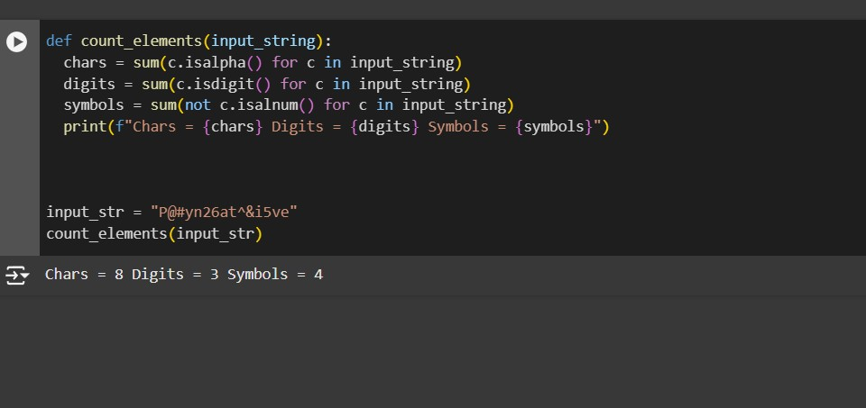

Output: Chars = 8 Digits = 2 Symbol = 3

1. Write a Python program to remove duplicate characters of a given string.

Input = “String and String Function”

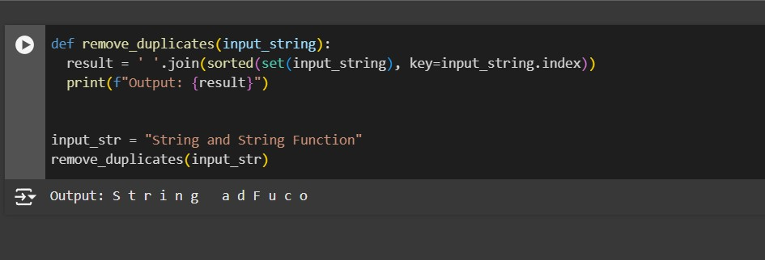

Output: String and Function

1. Write a Python program to count Uppercase, Lowercase, special character and numeric values in a given string

Input = “Hell0 W0rld ! 123 \* # welcome to pYtHoN”

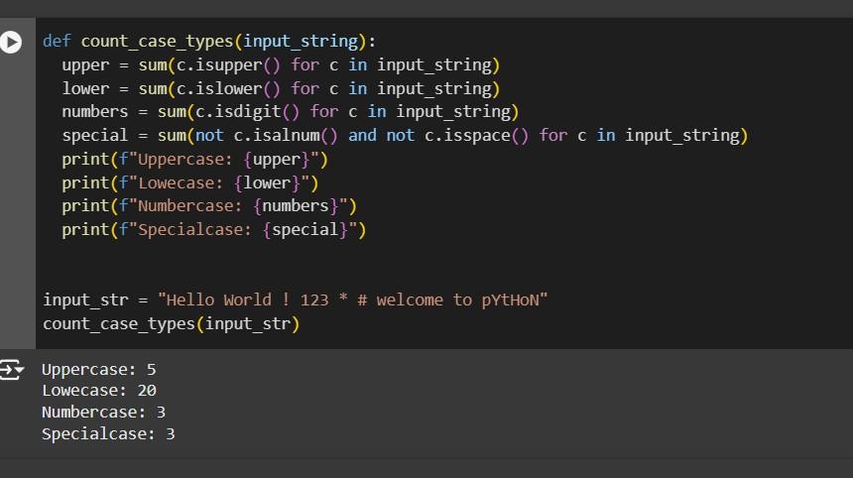

Output: UpperCase : 5

LowerCase : 20

NumberCase : 3

SpecialCase : 3

1. Write a Python Count vowels in a string

input= “Welcome to Python Assignment”

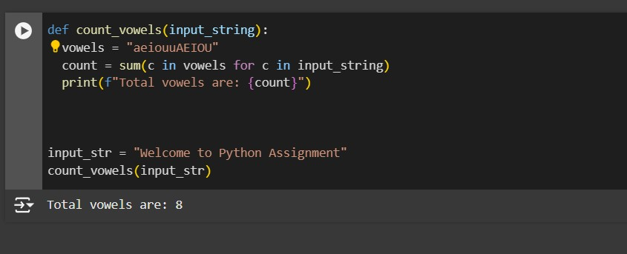

Output: Total vowels are: 8